Case Studies in Community Psychology Practice: A Global Lens

Thank you!

We want to thank you for joining us in creating this textbook which is the first known book dedicated to case studies in community psychology practice. We know that your contribution will add to this work in a significant and important way. We’re excited to be able to showcase your project with images, links to additional resources, embedded videos, blogs and more to highlight the dynamic versus static nature of community psychology practice work. We have included some examples of case studies that include visuals and other features for you to get an idea of the direction we are headed. It is a work in process so, we’ll figure out a number of the logistics as we move along. You will be able to see your work in progress on the Rebus Project page (which we will send out when ready) that will make it even more exciting as a living, breathing work!

What do we mean by case study?

Case studies for us mean the written result of capturing and recording the stories of community psychologists (CP) engaged in work in our communities (communities used broadly as this term is widening daily).

We are looking for this written work to be a vibrant portrayal of a project that is salient to you the author, and that you feel will be salient as a learning tool for community psychology undergraduate and graduate students. The project does not have to be perfect. In fact, grappling with community dynamics is a part of the real world of practice work so the inclusion of the ups and downs should be considered an integral part of the work.

Please note, the narrative portion of your work can include any research conducted beforehand, particularly participatory action research (PAR) or photovoice that you engaged in to inform the actual implementation of the intervention, prevention strategy or other work.
However, the bulk of the case study must be the implementation phase. For example, the research can be highlighted as the framework that informed the strategies and implementation of the solution.

Why capture case stories?

The purpose of capturing community psychology case stories for this book is to give undergraduate and graduate students an account of practice work that are instrumental in helping students move theory to praxis and practice. These case studies can be used in the classroom as learning material to offer them:

- Qualitative evaluation data which can be analyzed to identify themes and patterns that can be replicated to understand best practices, capture important components for future CP work and see the perspectives of community psychologists and members of the communities.
- A showcase of successes (e.g. the impact an engagement had on the community psychologist, community members and all others on the team (where appropriate).
- Illustrative examples of best practices and lessons learned to potentially avoid “sand traps”
- Material that can assist in raising their awareness about the needs, cultural expression and lived experiences of community members
- Ways to influence practice or policy

How and when should case stories be captured?

A template has been provided which is designed to help you write your case stories. Projects should use this template to submit a written version of each case story. If you have any photographs, recorded comments or even film footage to help illustrate the case story, please send these embedded in your case story by email.

Active links, videos, podcasts, other

You are free to embed videos, active links, podcasts or other into your narrative. Chapter pages
Your chapter should be no more than 20 pages including references, and less is best. Rather than using up your chapter page allocation with references, if you add a link at appropriate points, you can eliminate the references. A good example of this format that our book will take on is Lenny et al. (2019) Intro to Community Psychology Textbook. Please look through this book if you have not already done so. The link for the Introduction to Psychology book can be found here:

https://press.rebus.community/introductiontocommunitypsychology/

Five Key Points in Capturing Case Stories

- In capturing your case stories, it is important that the community members are viewed as the expert on their own lives - they should be as involved as possible in telling their story.

- Begin by explaining the purpose or big picture of the case story and gaining the community members’ consent for their stories to be used for learning and academic purposes (including a signed consent form if needed). Explain that their name and personal details will NOT be disclosed to anyone, and discuss whether there are any other identifying features which need to be changed to protect their privacy. This may not be needed at all, but we want to err on the side of caution.

- Talk about what didn’t work as well as what did! Identify any barriers faced and highlight any unexpected outcomes – good or bad (see specific structure below).

- Write clearly and simply avoiding jargon. Imagine your readers have little or no knowledge of your project or the kind of work you do.

- Use the template provided to help you record the case story. Please try and stick to the headings provided. If you need any help or advice, please contact Geri at gpalmer@adler.edu or communitywellnessinstitute@gmail.com

- We would like for you to stick to the template as much as possible, for a consistent look and feel of the book, but be creative as well. The use of images, videos, links, etc. are to your discretion.

Template or structure:

Name of project Name of author(s)
Email of contact person:
- About the community or big picture
- Background of how you came to work with this community
- Community needs
- Collaborative partners
- Description of the actual project.
- Outcomes and impact
- Lessons learned
- Looking forward
- Recommendations
- Show explicitly how the case study fits as a type of community psych practice (e.g. prevention, policy influencing, community organizing, creating alternate settings, etc.)

CONSENT
I give permission for the Case Studies in Community Psychology: A Global Lens project to use the information in this case story (including quotes) for inclusion in the Case Studies in Community Psychology: A Global Lens in order to illustrate impact and share best practices through academia and other practice venues. I understand that my identity will not be disclosed.

Signed………………………………………………………………………

Date…………………………………………………………………………

Your Name (print)…………………………………………………………..
CONSENT FOR USE OF PHOTOS / IMAGES
Where possible, we would like to include several images with each case story. Please supply photos or image that represents your case story.

Please sign below if you give consent for us to use your images in the book and / or use within national, regional or local media. Please tick boxes below as applicable:

- I give permission for this image to be used in the Case Studies for Community Psychology: A Global Lens including web based materials
- I give permission to this image to be used within national, regional and local media. Signed ……………………………..
Name (please print):………………………………….

Free Images

We have included resources here for finding free images that you might want to use for your chapters:

https://pixabay.com/ https://unsplash.com/
https://www.pexels.com/royalty-free-images https://www.freeimages.com/
Google Images

Go to Google.com (https://www.google.com/?hl=en)
- Type in Images
- Type in what kind of image you are looking for
- When you get to page where images show up, click on Settings
- Scroll down to “Advanced Settings”
- Scroll down to “usage rights” – “free to use, share, modify even commercially

NOTE: The editorial team reserves the right to change images for the look and feel and consistency of the book and also if the image cannot be used legally.

We look forward to working with you! Thank you again for your contribution! Editorial Team:
Geri Palmer Todd Rogers Judah Viola

Market advocacy to reduce newborn infections and deaths in Bangladesh

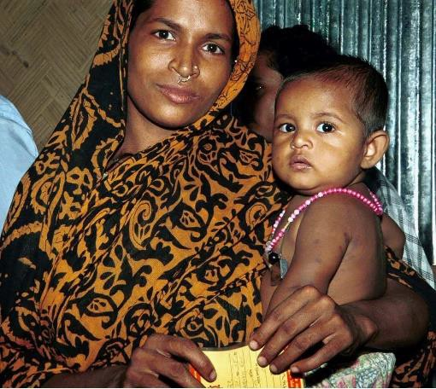
THE BIG PICTURE
Despite improvements in the neonatal mortality rate in Bangladesh, which has fallen by nearly 5 percent annually between 2000 and 2016, 62,000 infants still die each year. About one-fifth of newborn deaths in Bangladesh are attributed to sepsis, meningitis, or tetanus. Since the newly cut umbilical cord can be a pathway for bacteria, optimal umbilical cord care can help avert these deaths.
Regional randomized controlled trials have demonstrated that application of 7.1 percent chlorhexidine digluconate (CHX 7.1%) for umbilical cord care led to a 23 percent reduction in all-cause neonatal mortality. Reaching all newborns with this lifesaving medication proves especially difficult in a country where only 1 in 3 births takes place in a facility. Further, the majority of facility-based births occur in private-sector facilities, which is largely unregulated.
M.Dorgabekova
With support from PATH, the Bangladesh Paediatric Association (BPA)

undertook market advocacy efforts over an eight month period to engage public and private stakeholders to understand the existing and potential market for CHX 7.1%, current procurement constraints, and opportunities to overcome them in order to ensure access to CHX 7.1% at all births.

IDENTIFYING THE POLICY CHALLENGE AND OPPORTUNITY
In July 2013, Bangladesh’s National Core Committee for Neonatal Health within the Ministry of Health and Family Welfare (MOHFW) approved the new strategy for cord care—using CHX 7.1%. The new strategy states: “Irrespective of place of birth (home or facility) 7.1% Chlorhexidine aqueous solution should be applied to umbilical cord stump of every newborn immediately after birth, single application of 7.1% Chlorhexidine should be followed by dry cord care.” This represents a shift from previous policies, including the 2009 National Neonatal Strategy Guideline, which call for dry cord care—where nothing is applied to the umbilical cord and the area is kept dry and clean.
In 2015, the government of Bangladesh developed the Bangladesh Every Newborn Action Plan in alignment with the Every Newborn Action Plan endorsed by the World Health Organization, which includes the use of chlorhexidine for umbilical cord care. However, BPA recognized that realizing this cord-care policy

Chlorhexidine 7.1% has
proven effective in preventing infection and reducing neonatal mortality. Ensuring its availability at all births in Bangladesh—regardless of location—is critical to saving more lives at birth.

and program agenda would require provider and patient awareness as well as ensuring there is a sufficient supply of CHX 7.1% and it is available at public and private facilities as well as for home-based births.
Following two consultative workshops with key government stakeholders and development partners, BPA identified two advocacy objectives:
  - Incorporate the costed procurement plan of CHX 7.1% into the operational plan for 4th Health Nutrition Population Sector Program, (4th HNPSP) 2017–2020, Ministry of Health & Family Welfare.
Illustration: Tony Frye
  - Increase interest among private-sector stakeholders for manufacturing, distribution, and promotional activities of CHX 7.1% in Bangladesh.

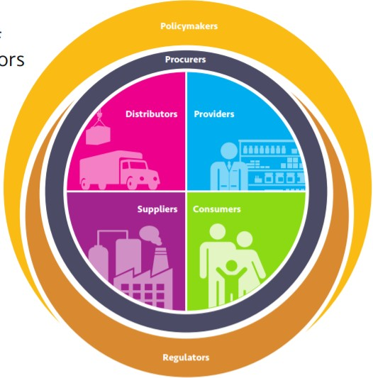IMPLEMENTING THE STRATEGY
Market advocacy works to influence the policy environment that governs how health markets operate—including all actors within the market—to ensure well functioning markets are realized. This means that products meet the 5A’s: that they are available, affordable, of assured quality, appropriately designed, and there is awareness of them among both consumers and healthcare providers. With support from PATH, BPA used market advocacy to ensure the policy, that all newborns in Bangladesh—regardless of place of birth—receive CHX 7.1%, is implemented as intended.
To do so, BPA first sought to understand the various market actors related to CHX 7.1%. Through research and consultation, they identified four major types of market actors that could be catalytic in increasing access to CHX 7.1%:
- Policymakers—Director General of Health Service (DGHS), Director General of Family Planning (DGFP) and Director General of Drug Administration (DGDA) within the MOHFW;
- Providers—specifically private practioners, hospitals, and clinics, as the majority of facility-based births occur in the private sector;
- Suppliers—namely ACI Limited, the only Bangladesh manufacturer of CHX 7.1% at present; and
- Market influencers—a range of partners, professional bodies, and organizations working together to increase knowledge and availability of CHX 7.1%.
Once the various market actors were known, BPA engaged them through a series of targeted workshops and interviews to facilitate information sharing among market actors that fostered increased awareness of current CHX 7.1% policy, and encouraged each actor to understand their role in implementation of the cord-care strategy.

Public-sector procurement
The 4th HNPSP is the operational plan that establishes the priorities of the MOHFW for accelerating progress toward health, population, and nutrition goals for 2017–2020. For CHX 7.1% to be prioritized and funded, incorporating a

Each market actor plays an important role in ensuring that products are available when and where they are needed. In this case, that means both the public- and private- sectors working to make CHX 7.1% available at all births, regardless of where they occur.

costed procurement plan in this operational plan is a critical first step. To do this, BPA leveraged their network of partners, including the Bangladesh Neonatal Forum and Saving Newborn Lives/Save the Children, to hold a stakeholder consultation. At the consultation, BPA presented evidence, collected through a document review and series of stakeholder interviews, focused on addressing current procurement challenges, gaps, and opportunities, and highlighting the need for inclusion of the costed procurement plan.
In addition to convening stakeholders, BPA also played a watchdog role, monitoring development of the HNPSP, to ensure the costed provision for CHX 7.1% was included in the final version. In doing so, it became clear that additional public-sector procurement challenges persist.
Within the MOHFW, both DGHS and DGFP provide health services to newborns at all levels of service delivery, with each wing governed by its own policies, systems, structures, facilities, and workforces. Reported challenges with public sector procurement include lack of data to drive procurement decisions, failure to adhere to best practices for product distribution and long order and lead times, which limit the useful life of the product. While both DGHS and DGFP included CHX 7.1% in their current operational plans, neither had executed on procurement during the life of this advocacy project so it proved difficult to identify and address challenges in their procurement processes.

Private-sector engagment in the maufacturing, distribution, and promotion of CHX 7.1%.
BPA used its convening power to engage private-sector stakeholders at various stages of the CHX 7.1% value chain.
BPA organized a stakeholder consultation with DGDA and manufacturers of other formulations of chlorhexidine to ensure that all clearly understand the current state of production and projected needs across the country. This consultation provided an opportunity to encourage manufacturers to enter the market for CHX 7.1% and gauge their interest to do so. BPA also met with Bangladesh Private Medical Practitioners Association (BPMPA) to push for inclusion of CHX 7.1% in the private sector to ensure successful implemention of existing recommendations.
Through consultation with ACI—currently the only manufacturer of CHX 7.1% in Bangladesh—BPA was able to understand current capacity and challenges it is facing. While ACI has sufficient procurement capacity to meet the expected needs (3.2 million units annually), it has yet to receive good manufacturing practices (GMP) certification, which would allow the manufacturer to sell to partners other than the government of Bangladesh, i.e. nongovernmental organizations and UNICEF. Since ACI is currently the sole producer of CHX 7.1%, stakeholders are concerned about the long-term affordability of the product and would like to see other manufacturers enter the market.

TOWARD ACHIEVING THE POLICY GOAL
BPA achieved one of its advocacy objectives, with the inclusion of a costed procurement plan for CHX 7.1% in the operational plan for 4th HNPSP. In addition to this policy win, BPA identified a number of ongoing challenges, and its
Flow of products in the two MOHFW systems.
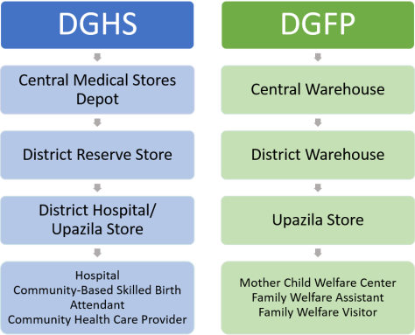

Misalignment in public- sector procurement policies through existing Ministry of Health and Family Welfare service delivery channels is one of several challenges impeding full access to CHX 7.1%.

advocacy around addressing the 5A’s of CHX 7.1% has already produced results from across various constituencies:

PATH’s 10-Part Approach to Advocacy Impact
Successful policy advocacy is guided by systematic analysis and pragmatic processes. PATH’s ten-part framework, outlined below, is a methodical approach to policy change that has helped over 600 individuals in more than 100 organizations in countries around the world achieve health policy change.
- Identify the advocacy issue
- State the policy goal
- Identify decision-makers and influencers
- Identify the interests of the decision-makers and influencers
- Clarify opposition and potential obstacles facing your issue
- Define your advocacy assets and gaps
- Identify key partners
- State the tactics you need to reach your goal
- Define your most powerful messages
- Determine how you will measure success
For more information and resources, and to find out how we can help, visit http://sites.path.org/advocacyandpolicy.
- Availability: To increase use in the private sector, BPA secured a commitment from BPMPA to introduce CHX 7.1% in its facilities, and if necessary will issue a letter to all private facilities regarding use.
- Appropriate design: DGDA has assured BPA that it will specifically include the 7.1 percent formulation of chlorhexidine in its essential medicines list as soon as possible. This addition will encourage manufacturers of other chlorhexidine formulations to produce CHX 7.1%.
- Affordability: In order to increase the number of manufacturers producing CHX 7.1% at an affordable price, BPA engaged representatives from these manufacturers who are now evaluating the market size and condition, and considering production of CHX 7.1%.
- Assured quality: Through BPA’s relationship with both ACI and DGDA, it has secured the commitment of DGDA to assist ACI, if needed, in completing GMP certification, ensuring that quality CHX 7.1% is available.
- Awareness: ACI as well as development partners—USAID, United Nations Population Fund, and Save the Children—plan to increase their promotional, social, and behavior change communications (SBCC) activities to increase awareness among health care providers.

LESSONS LEARNED
By seeking to understand the full market for CHX7.1% from production to use, BPA has been able to identify key gaps between the policy and full product availability and target its advocacy approach to address these gaps:
- Understand the policy environment. Key informant interviews and consultative landscaping of current practices and challenges helped lay bare the complexities of the public and private sector markets for CHX 7.1%.
- Foster increased coordination. BPA focused its advocacy on collective effort and served as a coordinator among various stakeholders to achieve advocacy goals, in this case helping a range of market actors better understand the role each plays in delivering CHX 7.1%.

LOOKING FORWARD
While strides have been made over the short duration of this advocacy project, there is more work to be done to realize the chlorhexidine policy and ensure that it is available for all births. Ideally, further in-roads will be made in the private sector to increase use among these disparate providers, and that the government’s intentions to ensure access to CHX 7.1% at all births will signal to additional private-sector manufacturers that they should enter the market. There may also be opportunities in the future to leverage government funds for SBCC campaigns related to newborn health and the UNICEF national newborn health campaign to increase awareness of lifesaving potential of CHX 7.1%.
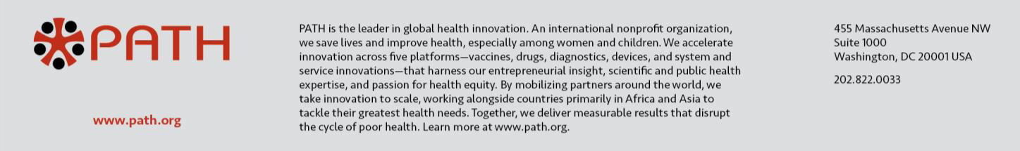
December 2017

ADVOCACY IMPACT CASE STUDIES

Ensuring government accountability for expanded access to female condoms in South Africa

THE BIG PICTURE

In South Africa, high rates of unintended pregnancy, maternal mortality, and HIV infection make it critical for women to have access to prevention tools that meet their needs. One important tool is the female condom, which the government of South Africa has promoted through its public- sector distribution program since 1998. However, despite marked interest and demand from women in the country, procurement and distribution of female condoms have remained relatively low over the years, especially in comparison to male condoms.
In 2012, the South African government launched a new National Strategic Plan on HIV, sexually transmitted infections (STIs), and tuberculosis (TB) for 2012-2016 that included ambitious female condom procurement targets. Reproductive health advocates viewed these targets as progress toward expanded protection options for women. They also saw an opportunity
to monitor and encourage implementation, especially since translating health policies into concrete programming remained a challenge in South Africa. Over 18 months, they implemented a series of advocacy activities to maintain a steady drumbeat of attention on female condoms and
increase accountability among South African officials for procurement and programming. The conclusion of these advocacy efforts coincided with the government releasing its largest-ever tender for female condoms, requesting a supply of 54 million units over three years. This number tracks closely with the targets laid out in the HIV/STI/TB National Strategic Plan.

IDENTIFYING THE POLICY CHALLENGE AND OPPORTUNITY

Female condoms are the only woman-initiated technology available today designed to provide “dual protection” from both unintended pregnancy and STIs including HIV. In South Africa, where women and adolescent girls have a great need for dual protection, female condoms offer an important prevention method. The South African government initially introduced

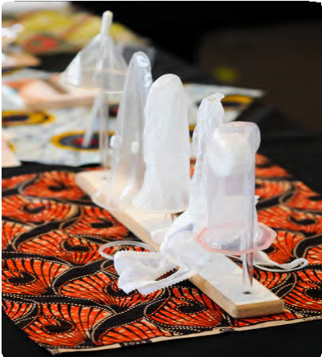
Female condoms are the only woman-initiated technology available today designed to provide “dual protection” from both unintended pregnancy and sexually transmitted infections including HIV.

PATH/Danny Ngan

female condoms in 1998 and today supports one of the largest public-sector female condom programs in the world. Still, the amount supplied by the government has not kept pace with demand. Whereas more than 350 million male condoms were distributed annually in 2008/2009, female condom distribution stood at approximately 3 to 4 million units—an inadequate number to meet the needs of all sexually active women and men in
the country.
In 2012, due in large part to ongoing demands from women’s rights and HIV/ AIDS groups, the South African government launched two new strategies calling for increased availability and distribution of female condoms. The National Contraception and Fertility Planning Policy and Service Delivery Guidelines placed strong emphasis on dual protection and enhanced female condom programming through primary health care and community-based distribution, while the four-year National Strategic Plan for HIV/STIs/TB increased female condom procurement targets to a record high of 25 million units in 2016/2017.
Sexual and reproductive health and rights advocates welcomed these policies but remained concerned that the policy targets would be confined to paper and not fully implemented. They felt that key government decision-makers lacked sufficient knowledge about female condoms and that this might affect ongoing commitment. They also wanted to ensure that policymakers would emphasize quality programming—including good counseling and a range of product choices—in addition to procurement numbers.
The launch of these two policies coincided with initial efforts by PATH and partners to bring the Woman’s Condom, a second-generation female condom developed by PATH and research organizations, to market in the country.
Given the organization’s long history of female condom advocacy and interest in creating an enabling environment for female condoms in general, PATH was eager to support an advocacy initiative in South Africa to help translate these supportive policies into practice through strengthened procurement and programming for female condoms.
To develop and implement the initiative, PATH partnered with Women in Sexual and Reproductive Rights and Health (WISH) Associates, a South African reproductive health and rights advocacy group. Together they conducted a joint advocacy planning process in early 2013 to identify goals, target policymakers, and key opportunities for influence. The outcome was a schedule of targeted activities over an 18-month period from April 2013 to October 2014 that would advance greater access to female condoms and keep pressure on government decision-makers to meet targets laid out in national policies.

IMPLEMENTING THE STRATEGY

The advocacy strategy outlined a steady drumbeat of activities to educate, inspire, and motivate decision-makers. Two of the most important events were a pair of high-level policy dialogues on female condoms, which were held in partnership with the Democratic Nursing Organization of South Africa (DENOSA) and brought together influential decision-makers from a range of

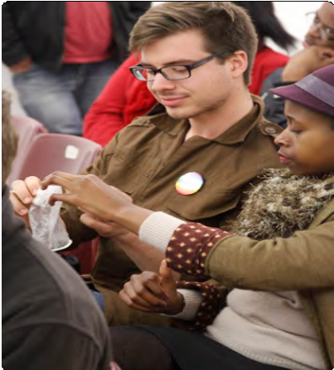
The advocacy strategy outlined a steady drumbeat of activities to educate, inspire, and motivate
PATH/Robert Hamlin
decision-makers. WISH Associates and PATH focused on keeping the issue—and the pledged commitments—visible to policymakers by utilizing individual influencers.

sectors to discuss policy opportunities and actions. During the meetings, organizers solicited action pledges from participants, including commitments by officials to advocate for condom choice and accessibility.
In the year following the first policy dialogue, WISH Associates and PATH focused on keeping the issue—and the pledged commitments—visible to policymakers by utilizing individual “influencers,” including journalists, civil society champions, and women and men with personal experience using female condoms. To generate quality media coverage on the topic, PATH and partners cooperated to conduct a journalist training and work with reporters to develop a set of “editors’ guidelines.” This training resulted in numerous articles and radio spots that helped maintain public visibility of
female condoms.
Civil society ambassadors were recruited to further spotlight the need for increased access to female condoms among their networks and through public forums. The ambassadors participated in awareness-raising events such as Global Female Condom Day, posted female condom messaging to their social media channels, and penned female condom articles and opinion pieces.
Additionally, through a collaboration with the African Gender Institute at the University of Cape Town, the Association for Progressive Communication, and I am Somebody, WISH Associates solicited “digital stories” from South African users of female condoms to document diverse women’s and men’s attitudes toward and experiences with female condoms and to illustrate demand for the product.
At a follow-up policy dialogue, PATH, WISH Associates, and DENOSA took stock of the stakeholders’ advocacy activities and progress. The dialogue suggested a sharpened interest and commitment to the issue. For example, a high-ranking National Department of Health HIV health official gave a
presentation stressing the government’s desire to work toward the 25 million procurement target in the National Strategic Plan on HIV/STIs/TB while
at the same time increasing the variety and number of female condoms in South Africa. Advocates also screened the female condom digital stories they had collected—attendees remarked that it was their first time hearing about real-life experiences with the product and that the stories strengthened their resolve to increase female condom availability.

ACHIEVING THE POLICY GOAL

In November 2014, the government released a three-year tender requesting supply of 54 million female condoms, tracking closely with the targets laid out in its National Strategic Plan on HIV/STIs/TB. The yearly procurement average of 18 million units in the 2014 tender represents more than a three- fold increase over the baseline of 5.1 million units procured in 2010. It also represents an increase over the November 2013 procurement tender for 15 million units, which was awarded to multiple female condom products.

PATH’s 10-Part Approach to Advocacy Impact
Successful policy advocacy is guided by systematic analysis and pragmatic processes. PATH’s ten-
part framework, outlined below, is a methodical approach to policy change that has helped over 600 individuals in more than 100 organizations in countries around the world to achieve health policy change.
- Identify the advocacy issue
- State the policy goal
- Identify decision-makers and influencers
- Identify the interests of the decision-makers and influencers
- Clarify opposition and potential obstacles facing your issue
- Define your advocacy assets and gaps
- Identify key partners
- State the tactics you need to reach your goal
- Define your most powerful messages
- Determine how you’ll measure success
For more information and resources, and to find out how we can help, visit http://sites.path.org/advocacyimpact

This achievement was due to several factors including an authentic commitment by the South African government to improve the health of women. The important work of champions to maintain pressure on
policymakers to keep their promises, however, demonstrates the value of advocacy in ensuring policy implementation. Advocates are now focused on ensuring that the government implements high-quality, accessible, and
comprehensive programming for female condom products while continuing to increase product procurement to meet demand.

FACTORS FOR SUCCESS

Ensuring a steady stream of coordinated actions helped keep the pressure on decision-makers and set a new standard for female condom advocacy. PATH, WISH Associates, and partners were able to take past advocacy efforts by reproductive health and rights groups to a new level through a dedicated and sustained push focused on female condoms. Previous advocacy related to female condoms had been primarily opportunistic and uncoordinated.
- Building local partnerships was key in holding the government accountable. PATH’s approach of coordinating and mobilizing local South African civil society and media partners to deliver advocacy messages was critical in persuading government decision-makers to act on their commitments.
- Using policy dialogues to discuss the female condom advocacy agenda helped create ownership by policymakers. The two policy dialogues facilitated broad buy-in from decision-makers to the advocacy agenda
and provided a forum for reporting on successes. This demonstrated how personalized and focused settings can offer a vehicle for reinforcing national-level commitments.
- Identifying creative methods for showcasing the issue can be an important way to reach policymakers. In addition to traditional policy dialogues and forums, PATH and WISH Associates used powerful multimedia productions on the female condom that illustrated demand and personal experience and provided justification for increasing procurement numbers.

Coordinating and mobilizing local South African civil society and media partners to deliver advocacy messages through
creative means—such as the “Dance4Demand” Global Female Condom Day campaign in 2014—was critical in persuading government decision-makers to act on their commitments.
PATH

PATH is the leader in global health innovation. An international nonprofit organization, we save lives and improve health, especially among women and children. We accelerate innovation across five platforms—vaccines, drugs, diagnostics, devices, and system and service innovations—that harness our entrepreneurial insight, scientific and public health expertise, and passion for health equity. By mobilizing partners around the world, we take innovation to scale, working alongside countries primarily in Africa and Asia to tackle their greatest health needs. Together, we deliver measurable results that disrupt the cycle of poor health. Learn more at www.path.org.
455 Massachusetts Ave NW, Suite 1000
Washington, DC 20001
www.path.org
February 2015

